* Link to Azure Noteook : http://bit.ly/2pXjMOd
* Evaluate your model accuracy:

Accuracy for all columns is : 0.9222222

Accuracy of pruned model for all columns is : 0.8333333

* Spend time experimenting with different setting for the treebasses

algorithms - such as pruning, binary branching, etc. to

see if you can improve the performance of your model.

prune_banktree <- prune(banktree, cp = 0.03)

* Review the structure of the tree

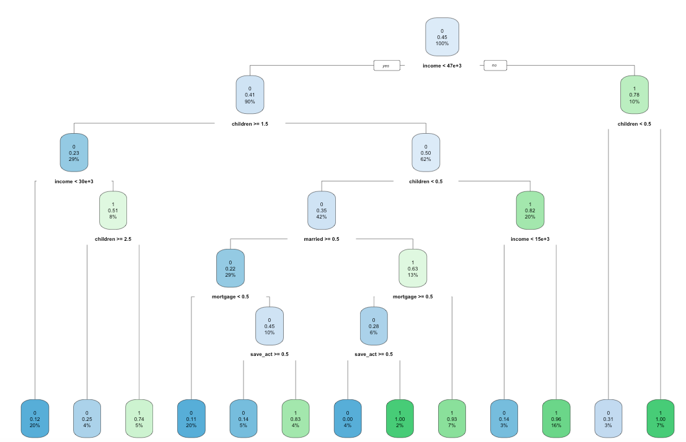

* Identify the more important feature information
* Generate the AUC for your final model.

0.829721362229102

* Show a screenshot of the final decision tree and model

accuracy statistics obtained from your

model.

